New Role Models
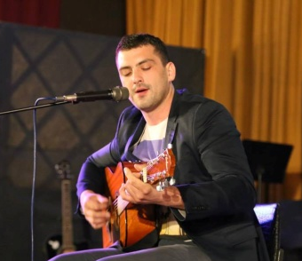
Dejan Roginić
Domain: car-mechanic, singer, actor, dancer
Country of origin: Donja Stubica, Croatia
Date of birth: 9th April 1990
Significant facts about his life:
- Finished VAT secondary school Oroslavje, car-mechanic
- Since age of five attended School of music –studied pianno
- Learned to play string instruments at School of music, played drums and percussion instruments
- At age of 14, founded his first group “BITTER SWEET”, the group split up after four years
- Has chosen to study solo singing, being thought by the most proficient opera singer Vlatka Burić Dujmović
- Has been actor at “Komedija” professional theatre
- Has been jazz/funk dancer at “JAZZELE” dancing club
- Participate at video shooting at CINEMATIX film studio
Achievements:
- Participated at art festivals Oro nota and The first voice of Zagorje, and Amateur singers festival Krijesnica
- Has been acting in musical play “Legenda Ružice grada”- Legend of Ružica castle” at Komedija theatre in Zagreb; chosen among 300 candidates, 12 candidates choosen (four men)
- Invited to take part in the first musical play “Zeleno blago” – “Green treasure”
- Wins many awards at Croatian car road-races

Reason for making this choice:
- We have chosen Dejan as a role model because he is persistent, has a strong personality, and above all he is very talented. He has proved that no achievement is impossible for somebody who has a strong will, who is willing to work hard, who is highly motivated, and who has a positive attitude.

