SREDNJA ŠKOLA BEDEKOVČINA
UČENIK: Toni Novak, arhitektonski tehničar
MENTOR: Sanja Markuš, d.i.a.
TEMA: Obiteljska kuća „Posejdon“

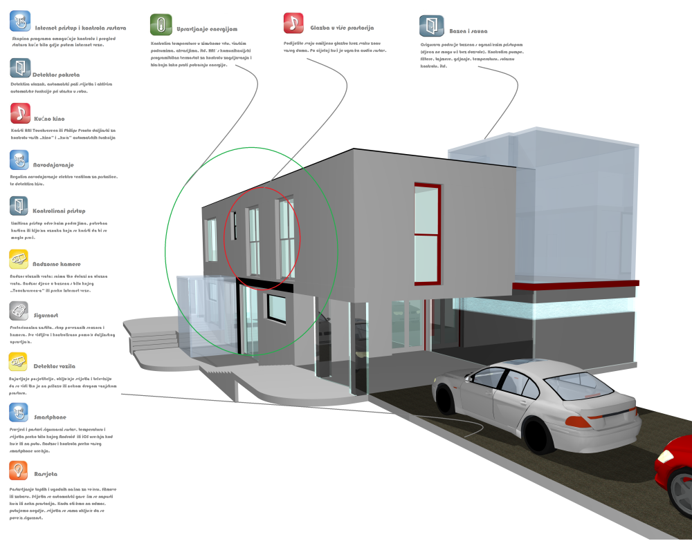
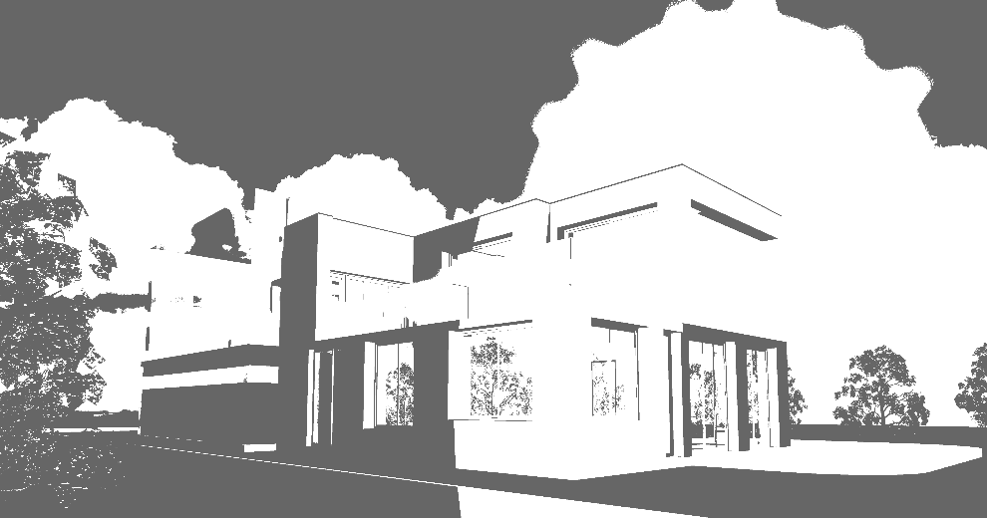
smart glass smart house zero energy house smart glass smart house zero energy house smart glass smart house zero energy house smart glass smart house zero energy house smart glass smart house zero energy house smart glass smart house zero energy house smart glass smart house zero energy house smart glass smart house zero energy house smart glass smart house zero energy house smart glass smart house zero energy house smart glass smart house zero energy house smart glass smart house zero energy house smart glass smart house zero energy house smart glass smart house zero energy house smart glass smart house zero energy house smart glass smart house zero energy house smart glass smart house zero energy house smart glass smart house zero energy house smart glass smart house zero energy house smart glass smart house zero energy house smart glass smart house zero energy house smart glass smart house zero energy house smart glass smart house zero energy house smart glass smart house zero energy house smart glass smart house zero energy house smart glass smart house zero energy house smart glass smart house zero energy house smart glass smart house zero energy house smart glass smart house zero energy house smart glass smart house zero energy house smart glass smart house zero energy house smart glass smart house zero smart glass smart house zero smart glass smart house zero
smart glass smart house zero smart glass smart house zero smart glass smart house zero
by T.N.

