EVALUATION OF THE SURVEY: Typical technical problems with bike!
NUMBER OF ANSWERS: 30 bikers from school
After evaluation we created the rang list of the most frequent problems with our bikers have during cycling:
- CHAIN PROBLEMS | 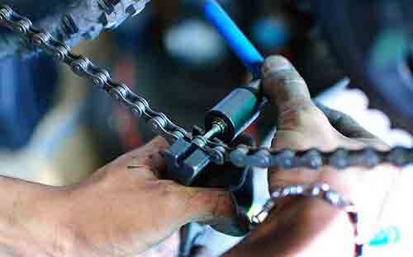
- FLAT TYRES | 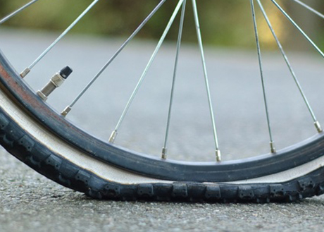
- ADJUSTING THE WHEELS | 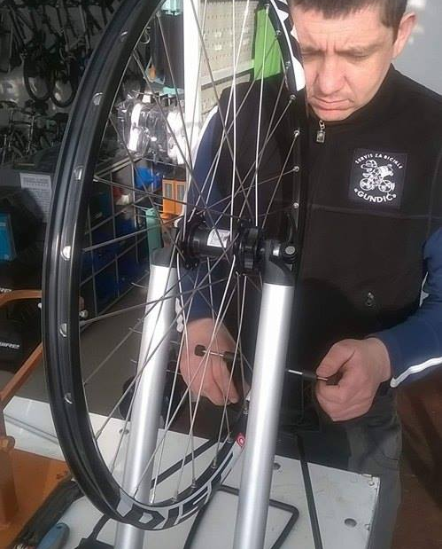
- REPLACING THE BRAKE CABLE | 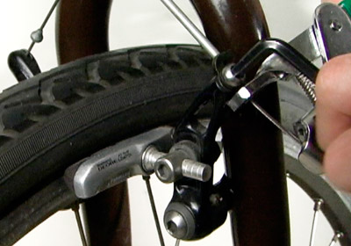
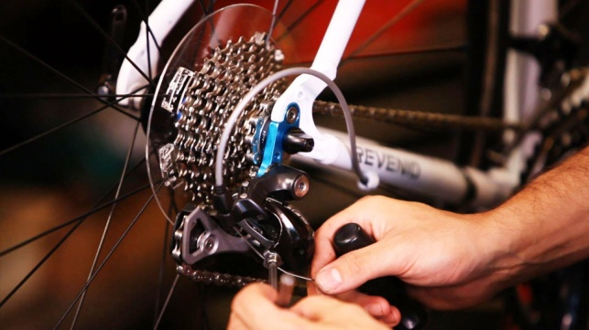

- ADJUSTING THE SPEED GEAR

As lots of our students are coming to school by bike so some ofthem (40%) know how to fix problems with their bikes.
They learned how to do it from their fathers or some adult person ( 50%) or on Internet (13%).
To create a list we had criteria – number of the most very frequent, then frequent….

If we want to se result od analise on each question:
      - How often do you ride the bike?

- How often do you have technical problems with your bike?

- Do you have the toolkit with you while cycling?

- Which are the most frequent technical problems with your bike? [problems with bike saddle]

- Which are the most frequent technical problems with your bike? [problems with pedals]

- Which are the most frequent technical problems with your bike? [flat tyres]

- Which are the most frequent technical problems with your bike? [chain problems]

- Which are the most frequent technical problems with your bike? [replacing the bike bearings]

- Which are the most frequent technical problems with your bike? [adjusting the speed gear]

- Which are the most frequent technical problems with your bike? [adjusting the wheels]

- Which are the most frequent technical problems with your bike? [replacing the bike taillights]

- Which are the most frequent technical problems with your bike? [replacing the brake cable]

- Are you usually able to fix problems with your bike on your own?

- If you are not able to fix the problems with your bike who repairs your bike?

- If you are able to fix the problems with your bike how did you learn how to do it?

